I Write your first nodejs Program.

Run the program using command prompt.

Run the program using Run And Debug option

Debug the program, apply breakpoint.

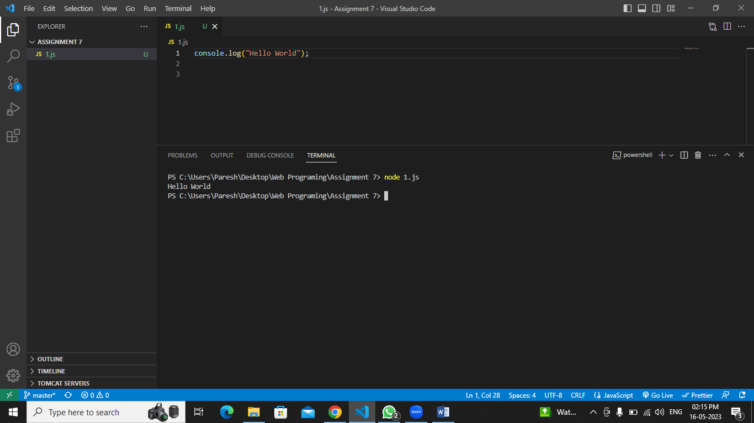

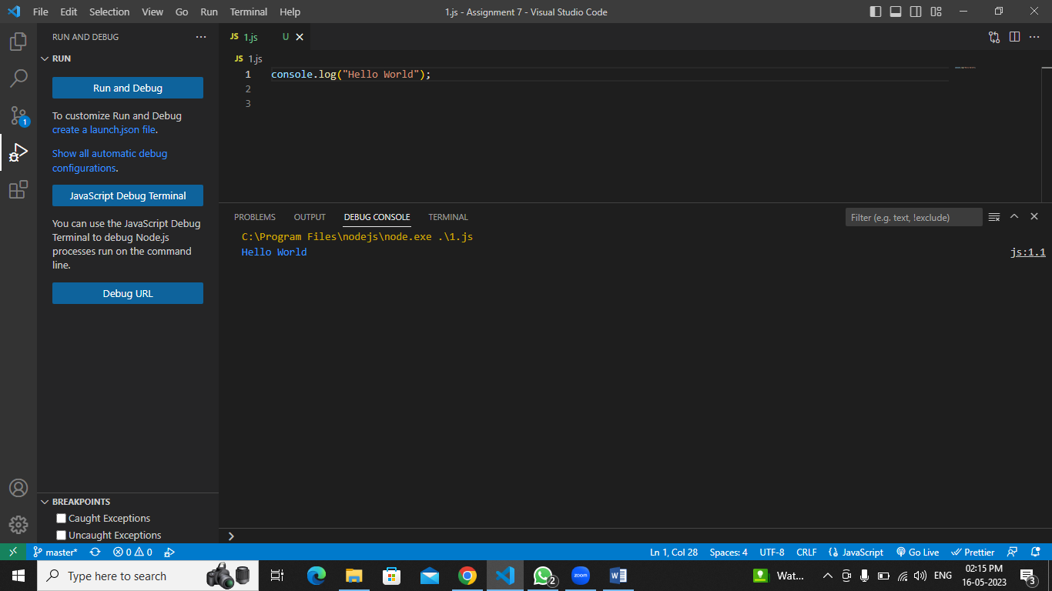

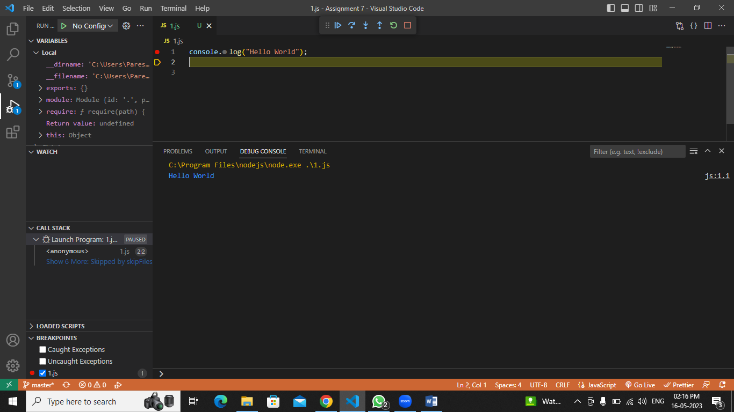

II Pattern Program - Print Star Ascending, Descending.

function assending(n) {

    let a = '';

    for (let i = 0; i < n; i++)

    {

        for (let j = 0; j < i;j++)

        {

            a = a + '\*';

        }

        a=a+"\n"

    }

    console.log(a);

}

function desending(n) {

    let a = '';

    for (let i = 0; i < n; i++)

    {

        for (let j = 0; j < n-i;j++)

        {

            a = a + '\*';

        }

        a=a+"\n"

    }

    console.log(a);

}

assending(5)

desending(5)

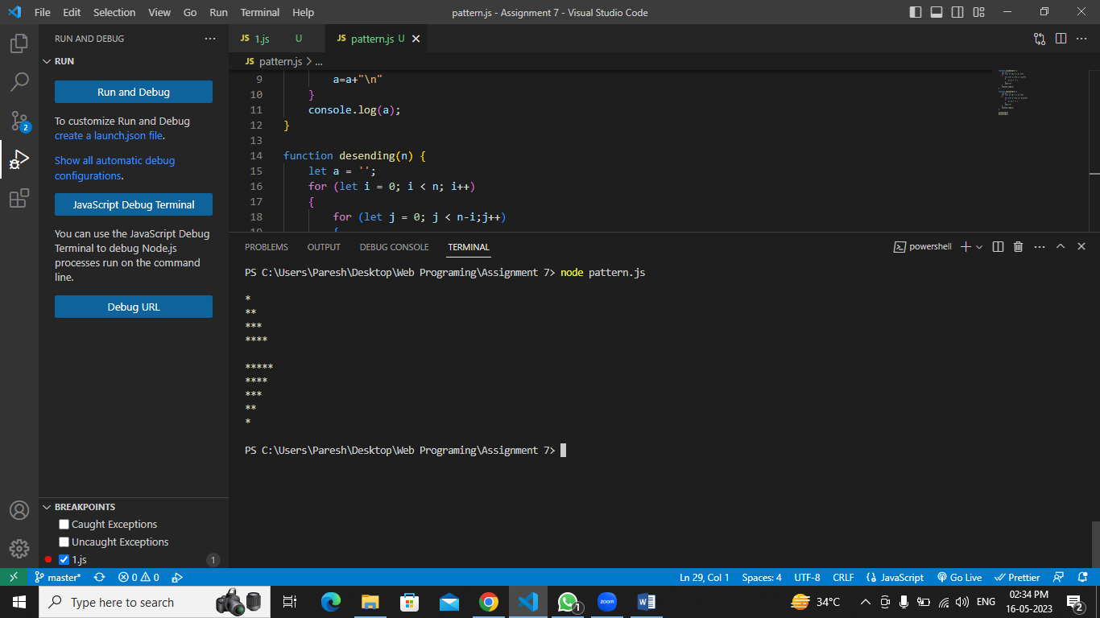

III Practice and display

1 Variable Declaration [Var Let Const Var vs let vs const ]

2 String Single quote Double Quote Backtick

let a = 10;

var b = 20;

var b = 30;

const c = 9;

let str = 'abc';

let str1 = "abc";

let str2 = `abc`;

console.log(a,b,c)

console.log(str,str1,str2)

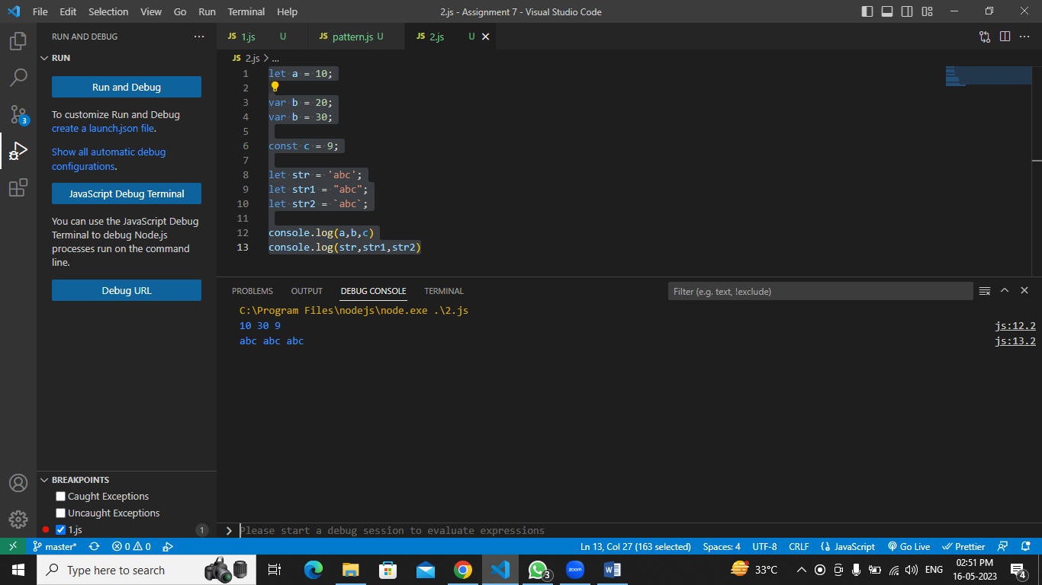

3 Writing if condition with Boolean String Number object

//using number

let a = 1;

if (a) {

    console.log("inside if ");

}

else {

    console.log("Inside else");

}

//using String

let str = "";

if (str) {

    console.log("inside if ");

}

else {

    console.log("Inside else");

}

//using boolean

let b = true;

if (b) {

    console.log("inside if ");

}

else {

    console.log("Inside else");

}

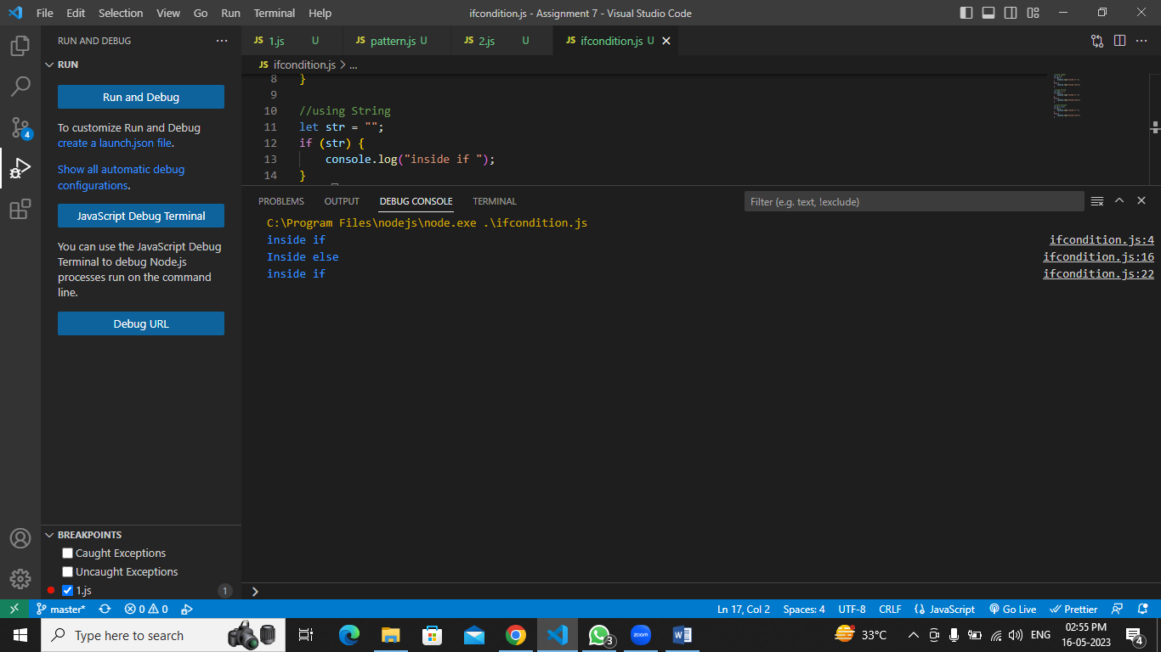

4 Basic for loop Advanced for loop forEach using callback

//simple loop

console.log("simple loop")

for (let i = 0; i < 5; i++)

{

    console.log(i);

}

//Advance loop

console.log("Advance loop")

let list = ["a", "b", "c", "d"]

for (let item of list) {

    console.log(item)

}

//ForEach loop using callback

console.log("ForEach loop using callback")

list.forEach((item) => console.log(item));

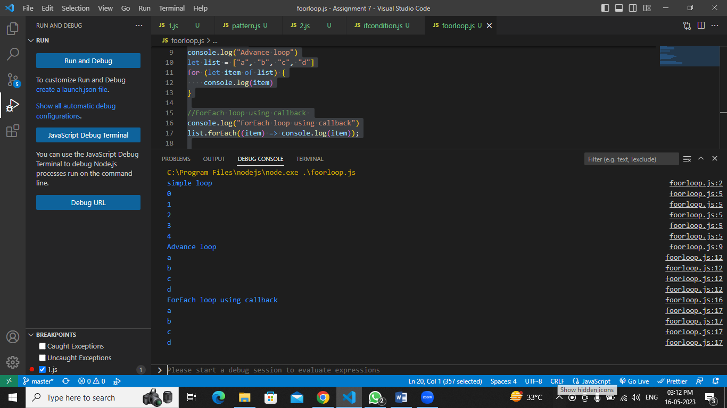

5 Create Named Function Overloaded Named Function Named function with default

value.

6 Create a named function - Call function with, 2 input param 0 param 1 param 2 param

3 param

7 Putting Condtion Putting shortcut using || By Default Value

console.log(`Function Overloading

calling function using different parameters`)

function mul(num1, num2)

{

    return num1 \* num2;

}

//Function Overloading

//calling function using different parameters

console.log(mul()); //with no parameters

console.log(mul(1)); //with one parameters

console.log(mul(3,5));//with required parameters

console.log(mul(8, 7, 2));//with three parameters

//Putting shortcut using || By Default Value

console.log("Putting shortcut using || By Default Value")

function add(num1, num2)

{

    num1 = num1 || 0;

    num2 = num2 || 0;

    return num1 + num2;

}

console.log(add(2));

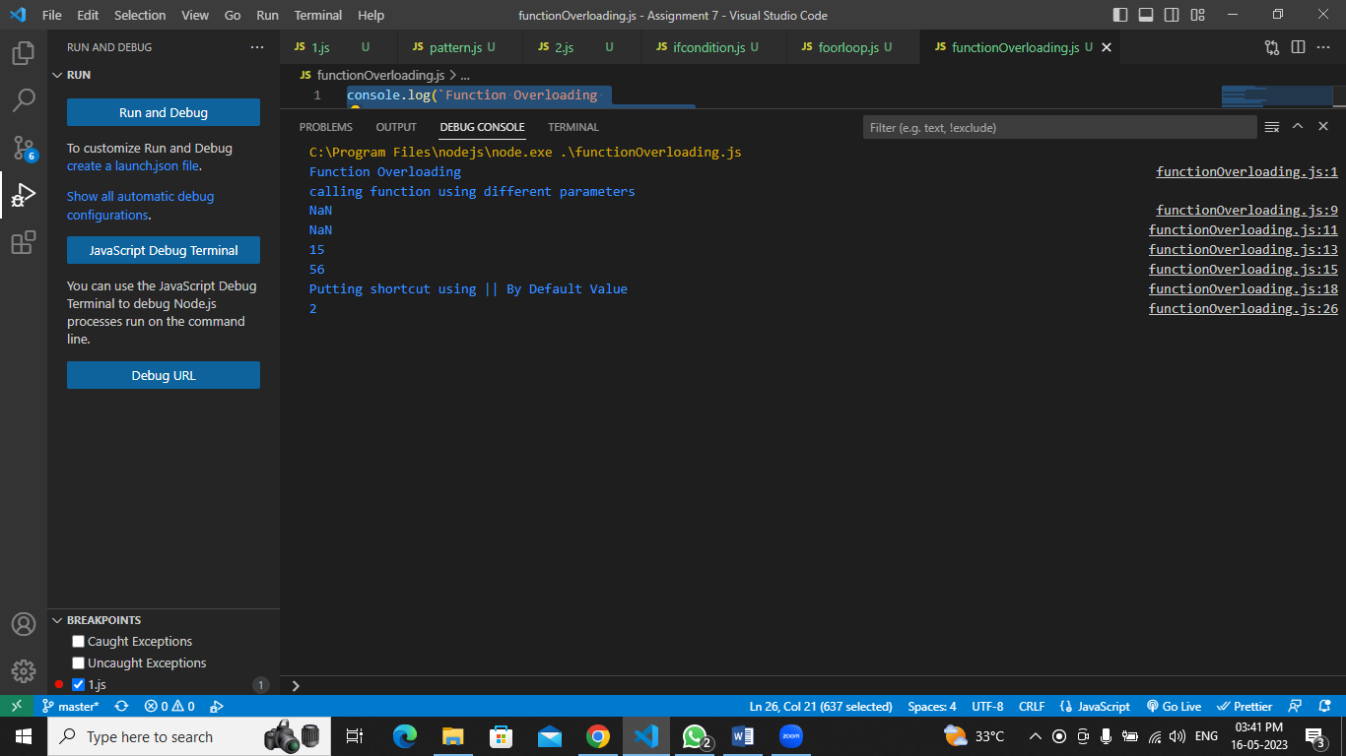

8 Define function that accepts unordered param - Pass all the param -Pass less param Define with default value - Accepts less param Pass more param.

function student(Rollnumber, name = 'Raj', subject = 'maths', marks ) {

    console.log(Rollnumber);

    console.log(name);

    console.log(subject);

    console.log(marks)

}

student(101, 'Paresh', 'history', 81);

console.log();

let name = 'Raj'

let subject = 'maths'

student(102, name, subject, 90);

student(103, 'Jitesh', 98)

student(104, 'Ramesh','English',98,67)

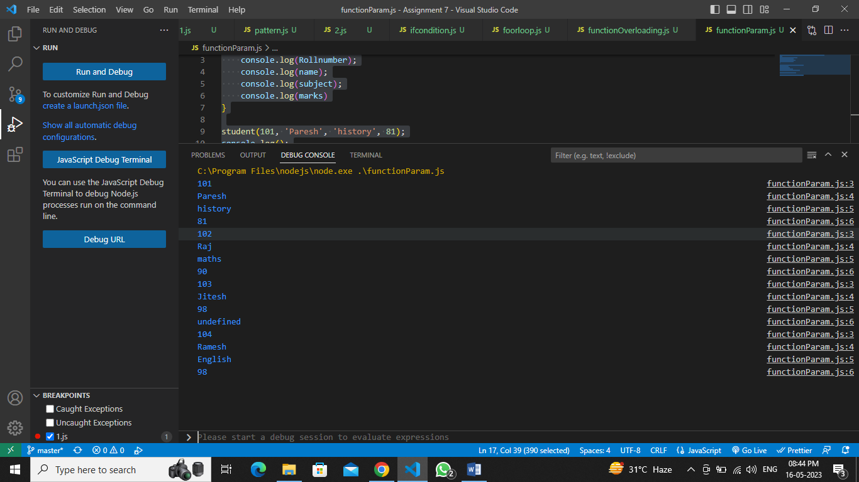

9 Create Anonymous Function Overloaded Anonymous Function Anonymous function

with default value

let mul = function (n1,n2) {

    return n1 \* n2;

};

console.log(mul(4, 5));

console.log(mul(5));

console.log(mul(10, 5,9));

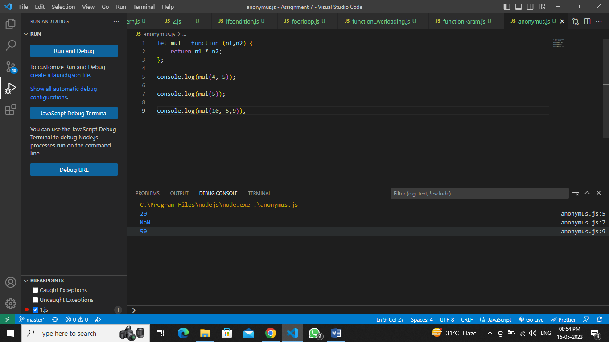

10 Create Arrow Function , Overloaded Arrow Function , Arrow function with default

Value

let div=(n1, n2) => {

    return n1 / n2;

}

console.log(div(6, 7))

console.log(div(6))

console.log(div(4,2,7))

